**EVEREST ENGINEERING COLLEGE**

**(Affiliated to Pokhara University)**

**Sanepa-2, Lalitpur**



**[Subject Code: CMP 290]**

**A MINI PROJECT PROPOSAL ON**

**“MCQ QUIZ EXAM”**

**Submitted by**

**Manish Rai [19120060]**

**Milan Bhattarai [19120063]**

**Prakash Thedi Magar [19120074]**

**Submitted to**

**Department of IT and Computer Engineering**

**March, 2021**

# ABSTRACT

This project report describes an MCQ QUIZ WEB APPLICATION exam of different subjects, named MCQ QUIZ EXAM, for students. This application is developed for educational purpose, allowing the user to prepare the multiple choice questions for different examinations. Any college or school with a computerized education system can adopt this system. The system will determine the participant’s performance depending on his answer and the next question will be generated according to the participant’s performance. Users can control the system in their own ways. The system will show result after the examination is finished and also be able to provide feedback according to the participant’s demand.

**TABLE OF CONTENTS**

ABSTRACT i

LIST OF FIGURES iv

LIST OF TABLES v

CHAPTER 1: INTRODUCTION 1

1.1 Background 1

1.2 Problem Statement 1

1.3 Objectives 1

1.4 Project Features 1

1.5 Feasibility Analysis………………………………………………………….. 2

1.5.1 Economic Feasibility…………………………………………………... 2

1.5.2 Technical Feasibility…………………………………………………... 2

1.5.3 Operational Feasibility………………………………………………… 2

1.6 System Requirement………………………………………………………… 3

1.6.1 Software Requirement………………………………………………… 3

1.6.2 Hardware Requirement………………………………………………... 3

CHAPTER 2: LITERATURE REVIEW…………………………………………….. 4

CHAPTER 3: METHODOLOGY 5

3.1 Introduction 5

3.2 Hardware and software requirement 5

3.3 Proposed system analysis 6

3.4 Proposed system design 7

3.5 Proposed project block diagram 8

3.6 Working principle 9

CHAPTER 4: EPILOGUE 12

4.1 Expected Output 12

4.2 Budget Analysis 12

4.3 Work Schedule 13

REFERENCES 14

CHAPTER 5: APPENDICES 14

# LIST OF FIGURES

**FIGURE PAGE**

Figure 1: V-Shaped Model 5

Figure 2: ER Diagram 7

Figure 4: Use Case Diagram 8

Figure 5: Block Diagram 8

Figure 6: Flowchart 10

# LIST OF TABLES

**TABLE PAGE**

Table 1: Budget Analysis 12

Table 2: Gantt Chart 13

# INTRODUCTION

## Background

This is a web-based multiple-choice-question examination system for accessing students. It is the system which students can appear in exam from anywhere and there is no interaction between pencil and paper rather interaction between computer and human being. The ‘MCQ QUIZ EXAM’ project will be developed to overcome the time consuming problem of manual system. This web application will check the correct answer and save the examiner time and carry the examination in an effective manner. Any university, college, school or educational institute can use this system to take quiz/exam. One of the benefits of our system is automated marking, that is teacher do not need to check the answer script as they do in manual quiz/exam.The users which are use this system don’t need to high computing knowledge and also system will inform them while entering invalid data. The project will reduce the manual process in managing examinations and all issues regarding that.

## Problem Statement

The aim of this project is to computerized the existing manual system and help the examiners to save their valuable time and important data. It is essentially required to assist students for the learning and preparation of different tests. This project helps the examiners to manage their services in a good way and provide a better service to their users.

## Objectives

The main objective of the project MCQ QUIZ EXAM is to manage the details of examinations, marks, courses and papers.

**Project Features:**

* To create an appropriate platform for best managing of MCQ test;
* To overcome the time consuming issues and taking MCQ tests;
* To release the marks of the test taker.

## Feasibility Analysis

Before developing this project, we need a feasibility analysis to understand whether the project would be successful or not. Feasibility analysis is detailed study of any system.

### Economic Feasibility

The economic analysis is to determine the benefits and savings that are expected from the candidate system and compare them with cost. The system is economically feasible, as the organization possesses the hardware and software resources required for the functioning of the system. Any additional resources, if required, can also be easily acquired.

### Technical Feasibility

It means that the project must be technically feasible by the use of present and near future hardware and techniques. Also it must be feasible to afford the technical person for new techniques or features required on the software project.

* Familiarity with Web Application.
* Familiarity with technology.
* The application is built in Microsoft word which MCQ QUIZ WEB APPLICATION, project members have extensive experience with.
* User have virtually experience using Microsoft word and all are comfortable using PCs.

### Operational Feasibility

The system operation is the longest phase in the development lifecycle of a system. So, operational feasibility should be given much importance. The users of the system don’t need through training on the system. All they are expected to know to operate the system is the basic netsurfing knowledge. It has user friendly interface.

### Time Feasibility

The user must know about the operation of software product to use it in the efficient way. Thus the process of operation must be pre-defined in many ways. Such as training, meeting, presentation demo etc. An example of an operational feasibility study would follow this path:

## System Requirement

In the overview of project of MCQ QUIZ WEB APPLICATION, there are some system requirements for the project to be done by the members. Software and hardware requirements are must to do the project.

### Software Requirement

* + Sublime text 3
  + Microsoft visio

### Hardware Requirement

* PC

# LITERATURE REVIEW

This project is inspired from Pathsala Nepal which provides medical quiz for various governmental and medical examination. Pathsala Nepal has hundreds of important GK questions with explanation on computers. These questions are important for governmental examination (like Loksewa) ponit of view and order crucial exams. Maths questions and answer are also available for Loksewa preparation. It includes interesting mathematics puzzles of algebra, arithmetic and geometric questions.

We also have refrence the MCQ web application Fantasia#2. This web application gives the general knowledge to children. Many random questions are present with randoms answers. The one important feature is that user gives the answer of one question within 30 second which is new features found found in this application.

MCQ web application named Trivia quiz by Wald Disney and others is our another refrence. This web application is about the movie Quiz, which name was “Fantasia”. Wald Disney released the experimental movie “Fantasia” to select the number of outlets in 1940, with disappointing results but it has since become a classic. It is the quiz about the movie “Fantasia”.

The Quizopedia is about the Nepal Quizzes and questions for students. The Quizopedia has a large question answer bank for kids for competitive exams. It boost up the student who are preparing the quiz contest competation about general knowledge. The quiz question are about Nepal history for general studies and others GK preparation are also available.

# METHODOLOGY

## Introduction

This chapter starts on the discussion about the project research, design and methodology. The second part presents the development of the system. The third part tells the operation process and testing. The last part, discuss the evaluation procedure.

In our project testing and verification take place in the early stage during the development stage. So we use V-Shaped model which is also the expansion of classic waterfall model and it's based on associated test stage for the every development stage.

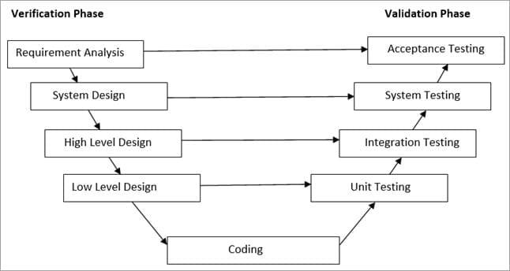

Fig1:V-Shaped Model

## Hardware and software requirement

In this project we use Html, CSS, JavaScript and php programming language. And for compilation of this language we use sublime text 3 compiler. And to make flow chart and the block diagram we use the Microsoft Visio 2013 software. We displayed the result by using desktop.

To search the needed data’s, we use the following browsers.

* + Mozilla Firefox
  + Google chrome
  + Internet explorer
  + Safari

Finally, we displayed the result by using desktop.

## Proposed system analysis

The fundamental idea in our project is to make a product that would offer new aspect of learning about the preparation for the entrance exam. During development, we worked out some guidelines for our application gameplay given as follows:

* Playing a round in a quiz should take less than 15 minutes.
* A large question sets containing 100 Questions of all subjects should take 90 minutes.
* Users should able to play the content they want to learn more about the curriculum subjects.

## Proposed system design

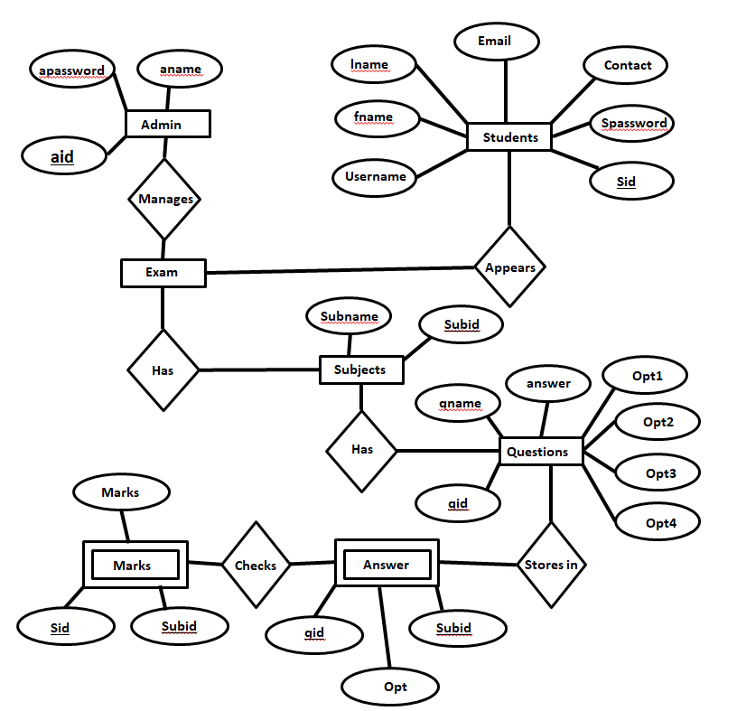

Fig2:ER Diagram

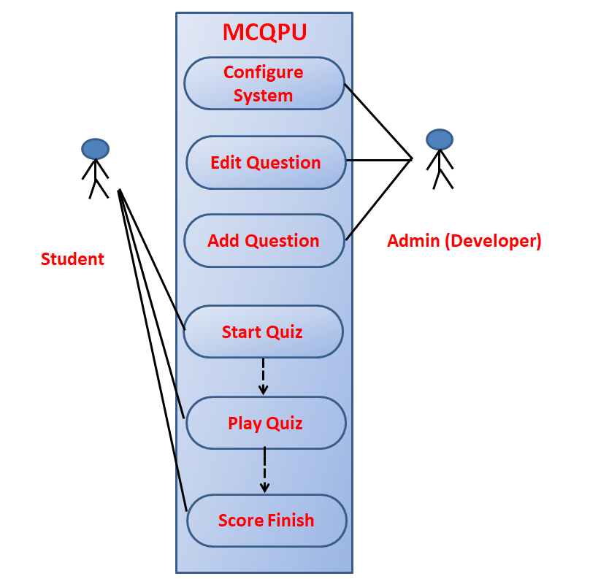

Fig4:Use Case Diagram

## Proposed project block diagram

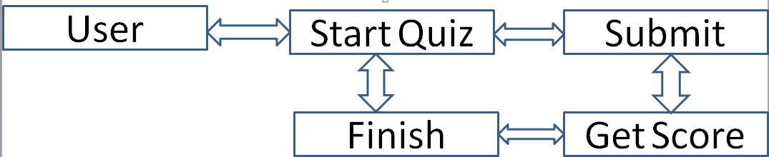

Fig5:Block Diagram

## Working principle

Firstly, the main thing which played vital role in the manufacturing of the software   
is indeed sublime text 3 compiler. Sublime text 3 complier is the software that we   
used for making our “MCQ QUIZ EXAM” software.

We followed the incremental model for the development of our project. As we only   
knew about the initial requirements of our project so we followed this method.

Incremental development is done in steps from analysis design, implementation,   
testing/verification, maintenance. Each iteration passes through the requirements,   
design, coding and testing phases. And each subsequent release of the system adds   
function to the previous release until all designed functionality has been   
implemented.

Therefore, we followed incremental model as we didn’t need to know the crystal clear   
requirements for the development of the project. We could add the extra features if   
we want during the development .The first increment is often a core product where   
the basic requirements are addressed, and supplementary features are added in the   
next increments.

**Algorithm:**

Step1: Start

Step2: Home

Step3: If user is registered.

Appear for exam

Go to step6

Else

Must be registered.

Step4: If user is admin.

Step4.1: add/delete subjects.

Step4.2: add/delete questions.

Step5: View results.

Step6: Display results.

Step7: Prints results.

Step8: Stop

**Flowchart:**

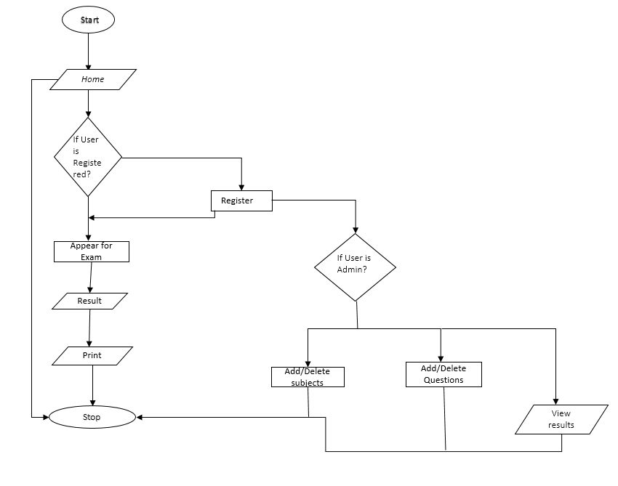

Fig6: Flowchart

**Description of Flowchart:**

First of all user must be register their user name, password, email, contact etc. After username registration, user can attend the exam/quiz which are taken by their administration. If the user is already registered then he/she simply login into the system. The questions are already set by admin and student should attend it.

If the user is admin then he can add/delete questions, add/delete subjects, and view the result of the student.

After a limited time exam is over, result is printed and user can view it.

**Description of block diagram:**

At the beginning user should be login and the subjects are available which exam is taken by teacher. Student must be complete the questions in limited time and result is shown. In admin side he/she can edit/delete subjects, edit/delete questions and set the time of exam and add the questions of each subject.

# Results and analysis

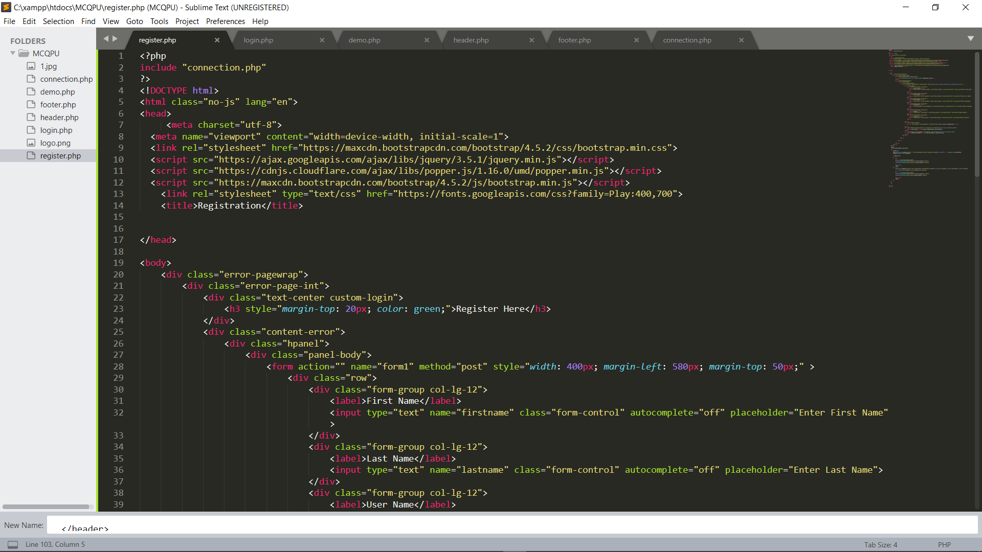

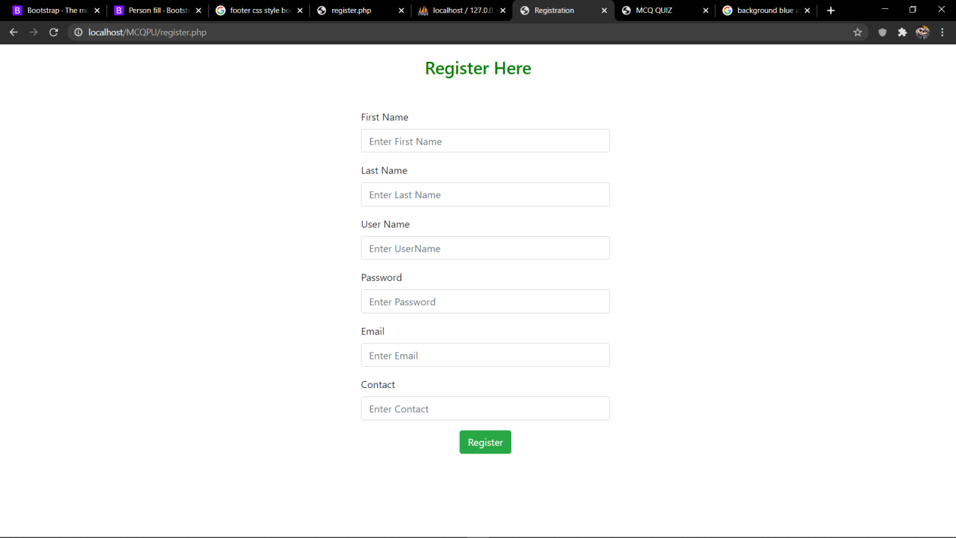

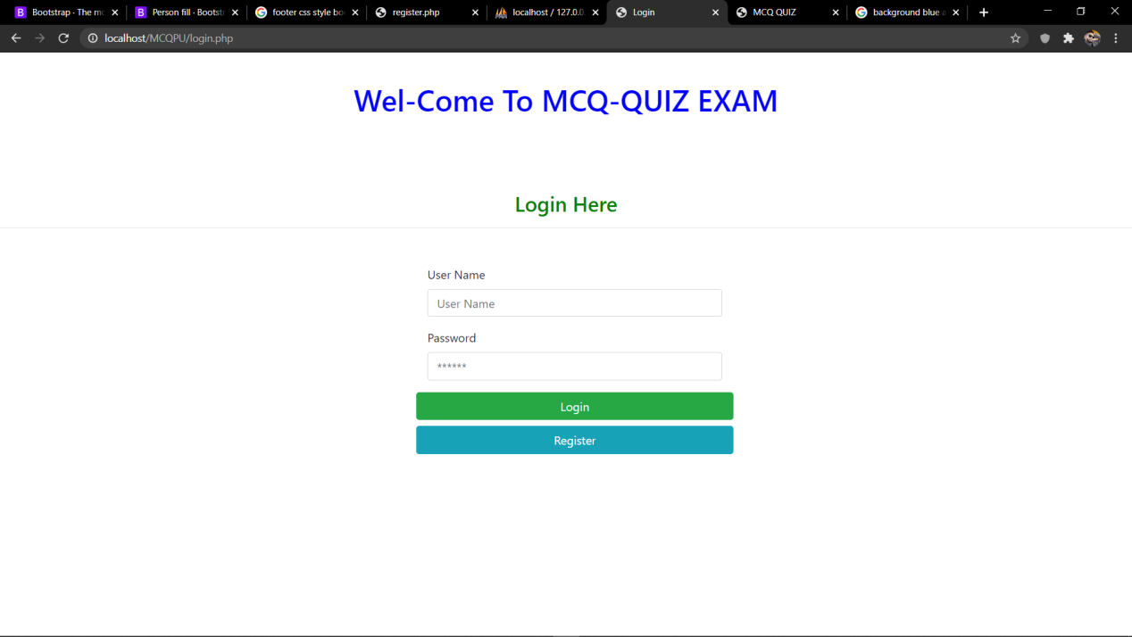

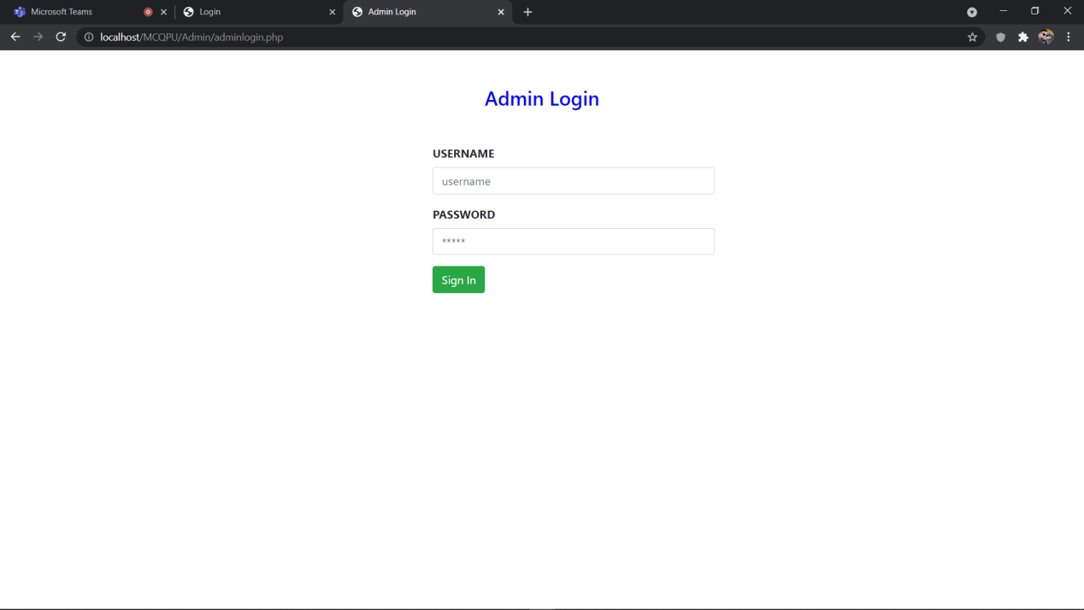

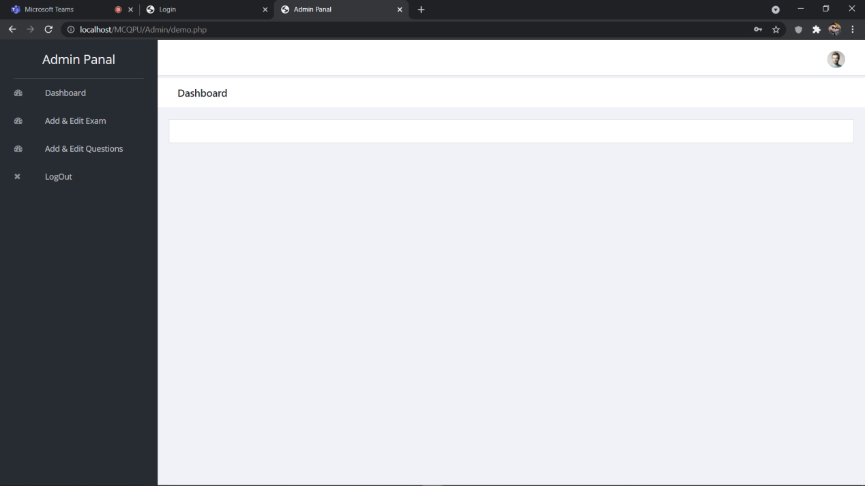

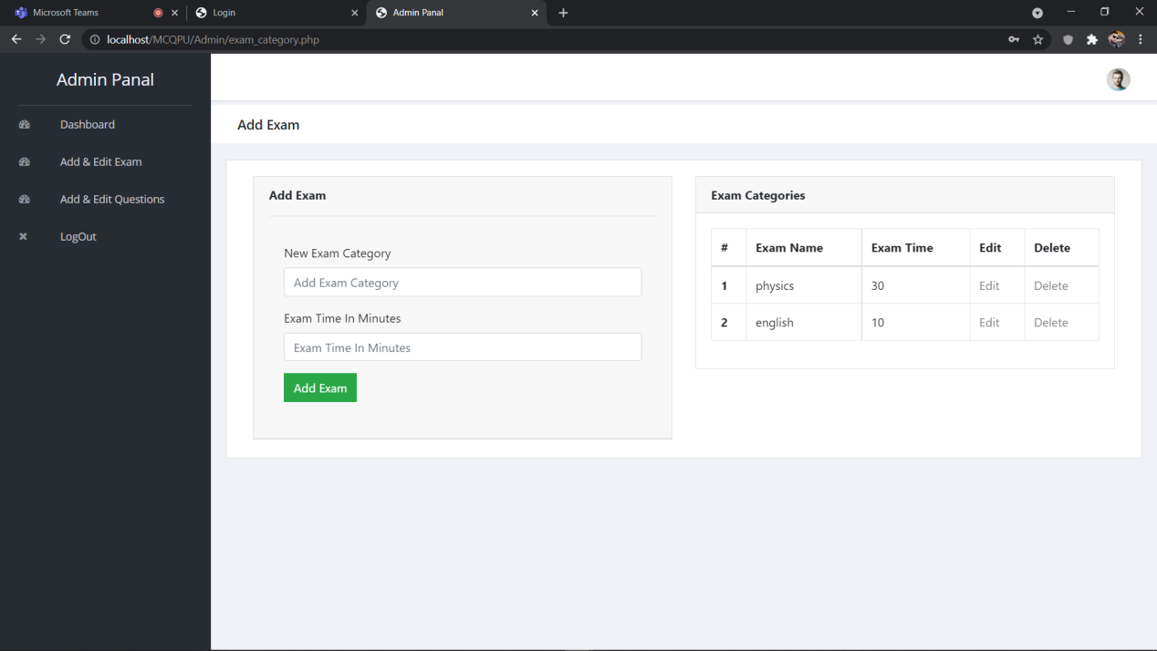

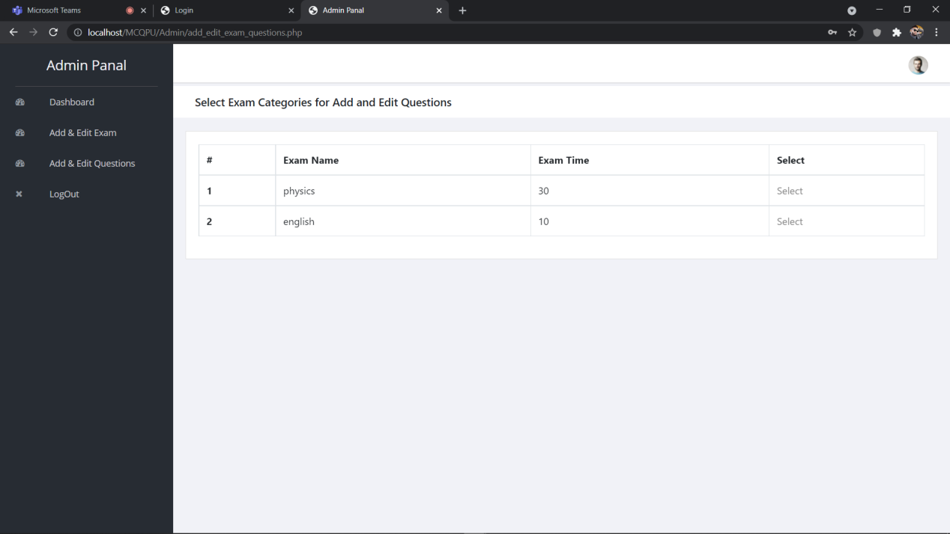

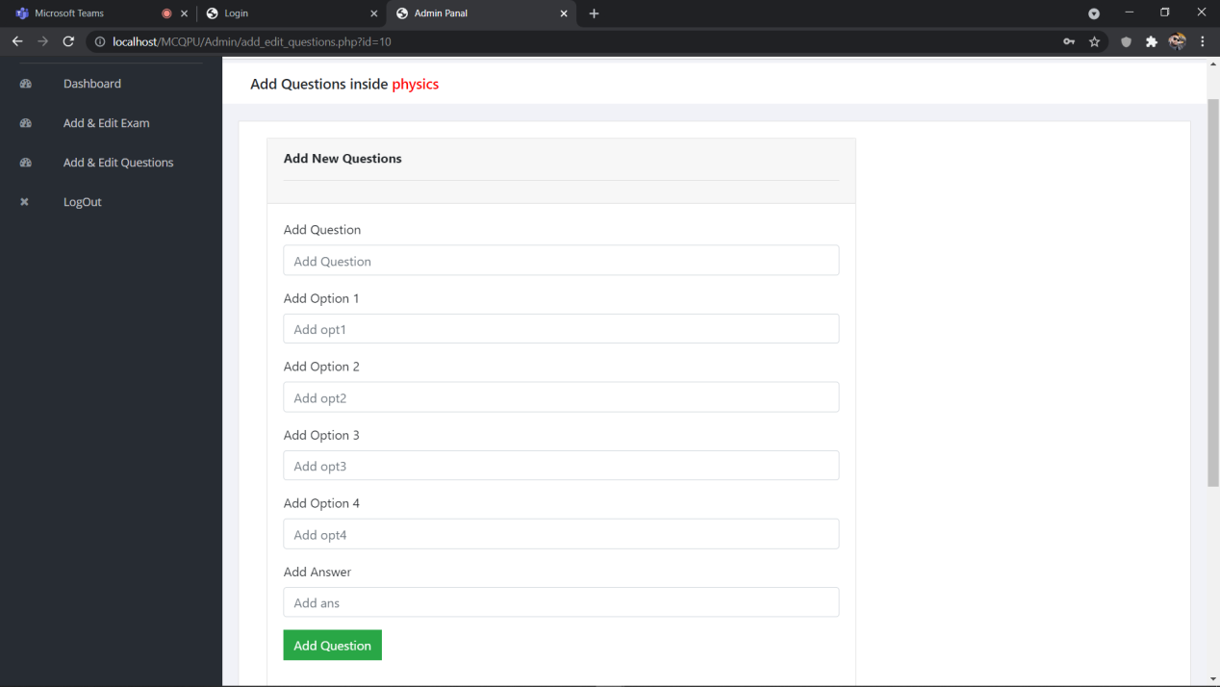

## Expected Output

The main purpose of our project is that offers new aspects of learning and improving knowledge in educational area. We have focused on the automated system, which replaces the manual quiz system. In this system, an educational institute can make their examination procedure automated.

## Budget Analysis

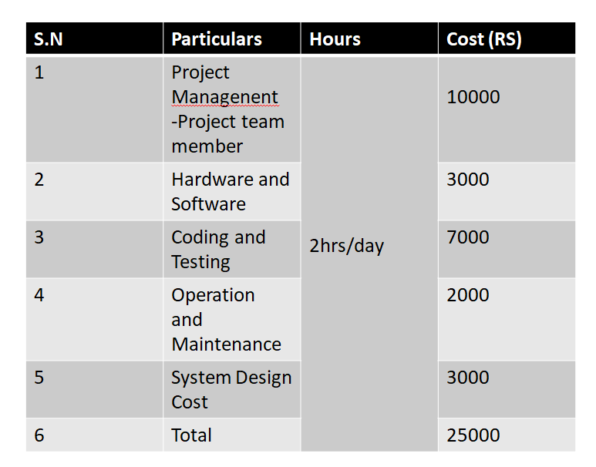

Table1:Budget Analysis

## Work Schedule

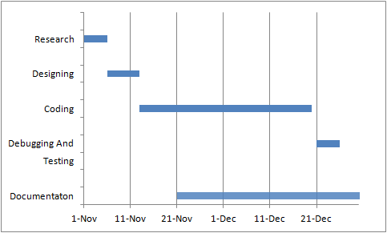

Table 2:Gantt Chart

# REFERENCES

[1] Jalote, P. (n.d.). *An Integrated Approach to Software Engineering.* Narosa Publication.

[2] Langanier, T. C.-L. (n.d.). *Object-Oriented Software Engineering.*

[3] Maxim, R. S. (2019). *Software Engineering.*

[4] Villa, I. S. (n.d.). *Software Engineering.* Pearson Education.